GPS Tracking System

**A PROJECT REPORT**

***Submitted by***

# ADITYA SHARAD PAWALE

*Under the guidance of*

# Prof. KHILLARI MAM

***in partial fulfillment for the award of the degree of***

**Bachelor of science**

in

# Electronic science



[Type text]

DEPARTMENT OF ELECTRONIC SCIENCE

# CERTIFICATE

This is to certify that the dissertation entitled “**GPS Tracking System**”

submitted by

**Aditya Sharad pawale** is approved for the award of Degree of Bachelor of Electronic science.

## EXTERNAL EXAMINER PROJECT GUIDE

**DATE: DATE:**

## CO-ORDINATOR DEPARTMENT OF ELECTRONIC SCIENCE

**DATE: 2022**

**ACKNOWLEDGEMENT**

I would like to express our special thanks of gratitude to our Guide – **Prof. KHILLARI MAM** who gave us the golden opportunity to do this wonderful project on the topic “**GPS Tracking System**” , which also helped us in doing a lot of Research and we came to know about many things We are really thankful to them. Secondly we would like to thank our parents and friends who helped us a lot in finishing this project within the limited time.

**Signature of the student Name of the Student:**

**ADITYA PAWALE**

**CONTENTS**

## Serial No Title Page no

1. **INTRODUCTION………………………….**
   1. PURPOSE
   2. SCOPE
   3. OBJECTIVE
   4. LITERATURE STUDY
      1. COMPONENTS
      2. POSITIONING
      3. NAVIGATION
      4. TIMING
      5. APPLICATION

## SYSTEM

**ANALYSIS…………………………………..**

* 1. SPECIFIC REQUIREMENT
  2. HARDWARE DESCRIPTION
  3. SOFTWARE
  4. DEVELOPMENT ENVIROMENT

## 3 DESIGN…………………….........................

* 1. SRS (Software Requirement Specification)
     1. Purpose
     2. Scope
     3. System Feature
     4. Functional Requirement
  2. OBJECT RELATIONAL MODEL
  3. SEQUENCE DIAGRAM
  4. ANALYSIS CLASS DIAGRAM
  5. ACTIVITY DIAGRAM

## OUTPUT AND REPORT………………………

1. **CONCLUSION &**

## FUTURE ENHANCEMENT…………………..

# INTRODUCTION:

A **GPS tracking** unit is a device that uses the [Global Positioning](http://en.wikipedia.org/wiki/Global_Positioning_System) [System](http://en.wikipedia.org/wiki/Global_Positioning_System) (**GPS**) to determine the precise location of a vehicle, person, or other asset to which it is attached and to record the position of the asset at regular intervals. The recorded location data can be stored within the tracking unit, or it may be transmitted to a central location data base, or internet-connected computer, using a [cellular](http://en.wikipedia.org/wiki/Cellular_network) ([GPRS](http://en.wikipedia.org/wiki/GPRS) or [SMS](http://en.wikipedia.org/wiki/SMS)), [radio,](http://en.wikipedia.org/wiki/Radio) or [satellite modem](http://en.wikipedia.org/wiki/Satellite_modem) embedded in the unit. This allows the asset's location to be displayed against a map backdrop either in real time or when analysing the track later, using **GPS tracking software**.

## Purpose:

A wide range of tracking systems has been developed so far tracking vehicles and displaying their position on a map, we can also use the system that has been developed to tracks the mobility of a human being. Now a day's tracking a person's mobility has become a crucial issue these days be it tracking a criminal came on payroll or a detective going to detect a case or any other utility.

## Scope:

Global Positioning System has numerous applications. The earliest application was military. Boaters were the first civilians to use GPS extensively for navigation, as dead reckoning is prone to error. Many high-end cars have a GPS navigation system which serves much the same purpose as a marine GPS. Some athletes are turning to GPS to track speed and distance. A few digital cameras have a GPS receiver which records the location where the picture was taken. So far, I've listed only one-way applications. Two-way applications include cell phones when calling the emergency number and vehicle tracking.

## Objective:

The global positioning system, more commonly referred to as GPS, is a radio frequency navigation system operated by the U.S. Department of Defense. GPS was originally developed for military purposes, but has since become available to non- military personnel worldwide as well. According to the National Executive Committee for Space-Based Positioning, Navigation and Timing, the objectives of GPS are to provide accurate positioning, navigation and atomic timing services on a continuous and free basis.

## Literature Survey:

* + 1. **Components :**

GPS is comprised of three main segments: space, control and users. The space segment consists of a constellation of U.S. satellites, placed so that at least three satellites are positioned above the horizon from any point on earth. PNT states that as of October 2009, 35 GPS satellites were in use. The control segment includes monitoring stations located worldwide charged with monitoring the GPS system. The user segment is made up of GPS receivers.

## Positioning :

GPS provides the user with a precise location by utilizing radio frequencies. The GPS receiver translates the information from at least three GPS satellites to provide the user with a two-dimensional location of latitudinal and longitudinal position on earth. If a fourth satellite is available, then the receiver can provide the user with three-dimensional location information, which includes altitude in addition to latitude and longitude.

## Navigation :

Navigation enables a user to process his current location based on GPS data and travel to his desired location, also based on accurate GPS data. Any user with a working GPS receiver can navigate to a particular destination, whether traveling on foot, by automobile, by airplane or by ship. GPS navigation is even accurate underground.

## Timing :

Time is the fourth dimension that GPS is set up to provide, by synchronizing each GPS receiver to the GPS satellites to provide accurate time to the user. The time is accurate to one hundred-billionth of a second. GPS receivers are able to perform this function because each GPS satellite includes several atomic clocks.

## Applications :

In addition to military use, GPS has multiple civilian applications. GPS has enabled many businesses to operate more efficiently and effectively by providing accurate time. Commercial and public transportation companies can save time and money by routing their carriers to less-congested areas. The average traveller can use GPS to find the nearest coffee shop, book store or gas station. GPS also can be used to enhance survival rates in search-and-rescue missions. The possibilities are endless, and as the use of GPS technology increases, so will the potential applications.

# SYSTEM ANALYSIS:

## OBJECTIVE:

The objective of this chapter is to study the specific requirement hardware , software design and its function.

## SPECIFIC REQUIREMENT:

NODE MCU can sense the environment by receiving input from a variety of sensors and can affect its surroundings by controlling lights, motors, and other actuators. The microcontroller on the board is programmed using the Node MCU [programming language](http://arduino.cc/en/Reference/HomePage) (based on [Wiring](http://wiring.org.co/)) and the Node MCU development environment (based on [Processing](http://www.processing.org/)). NODE MCU projects can be stand-alone or they can communicate with software running on a computer (e.g. Flash, Processing, MaxMSP).

The boards can be [built by hand](http://arduino.cc/en/Main/ArduinoBoardSerialSingleSided3) or [purchased](http://arduino.cc/en/Main/Buy) preassembled; the software can be [downloaded](http://arduino.cc/en/Main/Software) for free. The hardware reference designs (CAD files) are [available](http://arduino.cc/en/Main/Products) under an open-source license, you are free to [adapt them as](http://arduino.cc/en/Main/Policy) per yours project requirement.

## HARDWARE DESCRIPTION:

For the GPS tracking system we have three module that will be attached to each other . This three module together will perform as a GPS tracking system.

* + - Node MCU board
    - GPS shield
    - GPRS shield
    - Gsm module

## Node MCU board :

## The ESP8266 is, the name of a microcontroller designed by Espressif Systems. It is a self-contained WiFi networking solution offering as a bridge from the existing microcontroller to WiFi and is also capable of running self-contained applications.

* **Featured of NODE MCU Board**

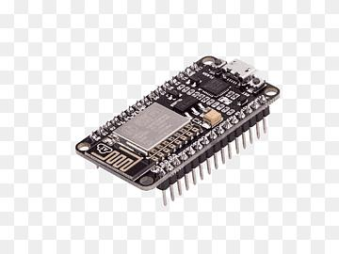

Microcontroller: Tensilica 32-bit RISC CPU Xtensa LX106.

* Operating Voltage: 3.3V.
* Input Voltage: 7-12V.
* Digital I/O Pins (DIO): 16.
* Analog Input Pins (ADC): 1.
* UARTs: 1.
* SPIs: 1.
* I2Cs: 1

## 2.2.2GPS shield:

Adding GPS to your Arduino has never been easier. The multiple GPS receivers attach easily to the shield, you will be able to locate your exact position within a few meters. Here's where we are. GPS also gives you amazingly accurate time! A GPS quick start guide is available for this product.

With the GPS Shield you can add GPS functionality to Arduino. A connector for the popular EM-406 GPS receiver is populated on the board, and footprints for EM-408 and EB-85A/FV-M8 connectors are also made available (connectors are not soldered on or included and can be found below in the related items). The regular GPS pins (RX, TX, PPS, etc.) are also broken out to a 10-pin 0.1" pitch header, and a small prototyping area is also provided.

The DLINE/UART switch switches the GPS module's input/output between Arduino's standard TX/RX pins or any digital pins on the Arduino (default setting uses pins 3 and 2 connected to TX and RX, respectively). The regular GPS pins (RX, TX, PPS, etc.) are broken out to a 10-pin 0.1" pitch header, and a small prototyping area is also provided. An ON/OFF switch is included which controls power to the GPS module. Additionally, the Arduino reset switch is also brought out.

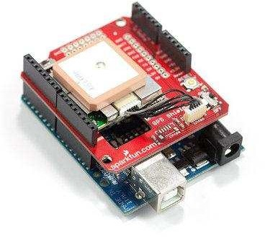

## Includes:

* GPS Shield
* EM-406 GPS Module
* EM-406 Interface Cable
* Set of Stackable Headers

## Features:

* EM-406 connector populated
* EM-408 and EB-85A connector footprints provided and connected for optional use
* UP501 connector and footprint
* Coin cell battery socket footprint provided and connected for optional battery backup of EB-85A GPS module
* Standard Arduino sized shield
* Prototyping area
* GPS serial and PPS signals broken out to a 0.1" header for additional device connections
* Arduino reset button
* DLINE/UART switch controls serial communications
* ON/OFF switch controls power to GPS module

## GPRS Module: ( SM5100B )

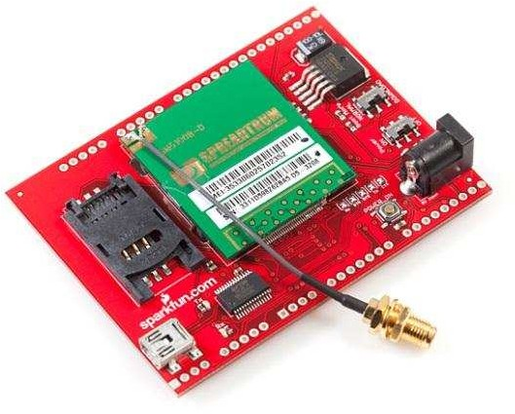

**Description:**

The SM5100B is a miniature, quad-band GSM 850/EGSM 900/DCS 1800/PCS 1900 module, which can be integrated into a great number of wireless projects. You can use this module to accomplish almost anything a normal cell phone can - SMS text messages, GSM/GPRS, TCP/IP, and more!

This module features two UARTS, an SPI interface, and two 10-bit ADCs. It also supports Li-ion battery charging, a 4x6 keypad, and an LCD interface. Inputs/outputs are available for a speaker and microphone. An antenna does come attached to the module.

Power supplied to the module should be regulated between 3.3-4.2VDC (3.6V nomina).

# 3 DESIGN:

There are already a lot of applications which use the geo-positioning. Garmin, one of the famous GPS manufacturer, proposes maps of almost every countries in the world ready to be download into their panel of GPS devices. Different kind of applications for different kind of public: road maps and tracking, topologic maps for technical job like geologist (for instance), light’s map for pilots, etc.

Also it exist, for mountain activities like free ride, hacking, those automatic signaling systems which switch on as soon as the rider get caught by an avalanche for example. It transmits a radio signal to the closest relay and indicate the exact position of the victim. It helps for the search and often save lives. The portable Tom-tom GPS proposes a full navigation system with vocal indication.

The list of geo-positioning applications is huge and a simple search on the Internetgives hundred web sites talking about the topic.

## USE CASE Diagram:

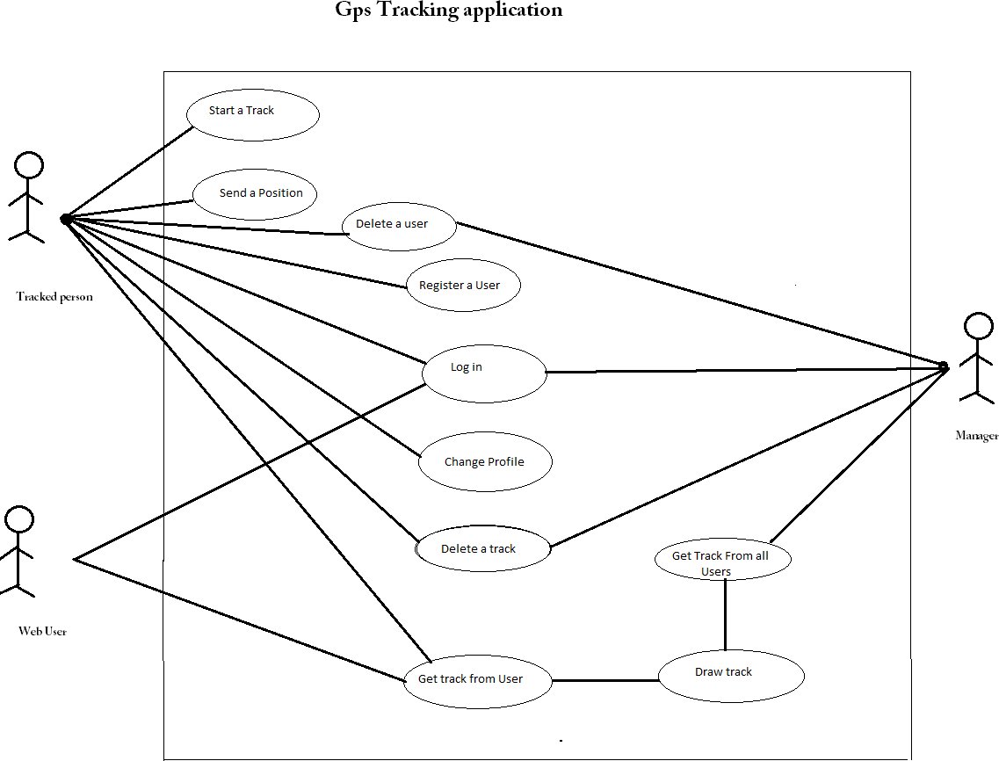

Figure -2

* 1. **SRS(Software Requirement Specification):**

## Purpose

The Software Requirement Specification (SRS) will provide a detailed description of the requirement for GPS Tracking System . This SRS will allow for a complete understanding of what is to be expected of the GPS Tracking System to be constructed. This SRS will used for constructing.

## Scope

The GPS tracking system will enable a user to track online any object attached with tracking device through a browser , for security, location, route planning purposes .

## System features

* + - 1. The system should provide current location of the object being tracked at request.
      2. The system should log position of the object being tracked at a fixed interval of time.
      3. The system should let admin to delete or edit location log .

## Functional Requirement

* + - 1. **Parse Locations**

Description : This function will run on the device at every fixed interval of time to read the input from GPS receiver and get the location data.

Input : NMEA String from the GPS receiver. Output: Location data and time stamp.

## Send Location

Description : This function runs on the device to send the location data and time stamp to the server. On receiving the time stamp from the server it knows that the location data has been logged for the said time

Input: Location data and timestamp . Output: Time stamp.

## Update Log

Description : Stores the location data received to the table.

Input : Location data and timestamp Output : Time stamp of the updated entry .

## View Log

Description : Function to view the log. Input : Request to view the log . Output : Logged location data.

## Delete Log Entry

Description : Allows admins to delete logged entry Input : Time stamp of the entry.

Output : Entry deleted acknowledgement .

## Show Location

Description : Allows user to get current location of the device or the location at a given time.

Input: Time stamp

Output : Location at the given time

## Diagrams

**GPS Tracking and Location :**

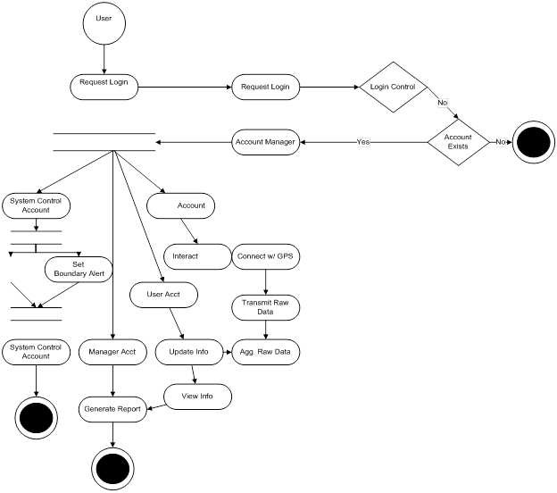

Figure -14

**Two Way Communication :**

No

Account Exists

Set Privledges

Account Manager

Yes

No

Enter Message

User

Request Login

Request Login

Login Control

Receive

Message

Send

Message

Update Log

View Log

Figure -15

Output:-

Global Positioning System to determine the precise location (Longitude & Latitude) of a vehicle, person, or other asset to which it is attached and to record the position of the asset at regular intervals. The recorded location data can be stored within the tracking unit, or it may be transmitted to a central location data base, or internet-connected computer, using a cellular (GPRS or SMS), radio, or satellite modem embedded in the unit. This allows the asset’s location to be displayed against a map backdrop either in real time or when analyzing the track la

# CONCLUSION & FUTURE ENHANCEMENT

A GPS also known as a Global Positioning System is a great technology that is used to track objects around the world. The technology was developed by the US military in an attempt to make success more seamless for the military – this technology is now being used all over the world and it is highly reliable that it is very clear that this technology will be of more importance in the near future. You might hear about the latest GPS tracking system making the buzz or who made or is using the technology most but the fact is, what matters most isn’t the origin of the technology or who uses it but what is in it for you. There is no point in using something if you won’t be gaining anything from it. Many companies use GPS fleet tracking software with their service employees and this has helped them reduce fuel costs and increase work productivity. Below are some major advantages of using a **GPS tracking system**.

Advantage:

GPS Tracking System Can be Used to Locate Lost Items:

The crime rate keeps on increasing in every part of the world and a lot of highly valuable objects have been, and will, be stolen. It doesn’t matter how irrelevant you think an object or equipment is to others if it is something that is very expensive you should make sure you install a *GPS tracking system* on it; for example, a $2 million violin was once stolen from a café in London and the owner had a hard time finding it, if the owner of this highly expensive violin had installed a GPS tracking system in her violin it will be very easy for her to locate it.

It is almost impossible to reduce the crime rate in the world because new technologies are emerging and it is new technologies that encourage crime and stealing; however, you can make it easier for you to track any valuable object you own by installing a GPStrackerinit.

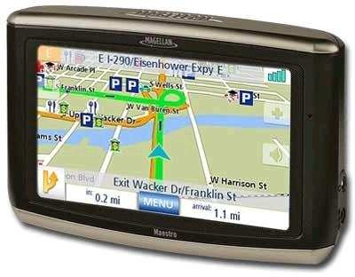

GPS Tracking System Can be Used to Track Things and People:

One great function of a GPS tracking system is that it can be used to track anything irrespective of it being static or flexible, it can also be used to track people and animals depending on what you need it for. Another great feature of a GPS tracking system that makes it better is the [alarm system it has](http://techgyo.com/index.php/5-free-android-apps-one-must-install/); for example, you can easily install a GPS tracking system in a vault where valuable goods are so that you can be alarmed anytime someone is trying to steal them. You can also use the GPS [technology](http://techgyo.com/index.php/how-to-map-the-location-or-picture-in-g-o-o-gle-earth-2/) to ensure things are going fine with people working for you especially if they’re doing a job that requires a high level of security and confidentiality; this will be able to track them anywhere they go and when they go there.

GPS Tracking System Can be Used Anywhere in the World:

An added advantage of the GPS tracking system is that it can be used anywhere in the world; it doesn’t matter whether you’re in Africa or Asia the GPS technology is powered by the world satellites and this means it can be accessible anywhere; all you need is a solid tracking system and a GPS receiver.

## Disadvantages:

* Sometimes the GPS may fail due to certain reasons and in that case you need to carry a backup map and directions.
* If you are using GPS on a battery operated device, there may be a battery failure and you may need a external power supply which is not always possible.
* Sometimes the GPS signals are not accurate due to some obstacles to the signals such as buildings, trees and sometimes by extreme atmospheric conditions such as geomagnetic storms.

## Benefits:

* Benefits include the prevention of labor fraud, speeding, idling, unauthorized vehicle usage, and more. Here are a few of the most common benefits immediately experienced by GPS Insight clients.
* For parents, it takes some of the worry out of your kids driving long distances home from college. You know where they are and when to expect them home.
* For baby-boomers, the shoe is on the other foot - it helps to take some of the worry out of your elderly parents driving home from vacation or just driving

## 

around town. You know where they are and this allows them to be more independent.

* GPS tracking is customer service at its finest. You know instantly which of your drivers is closest to the customer needing help.
* Imagine how thrilled your customers will be when you can tell them exactly when to expect their delivery!
* For employers, using GPS tracking allows you to know how fast your employees are driving, how long a break they are taking (vehicle hasn’t moved), and if they are where they say they are!
* GPS tracking also allows you to monitor fuel usage based on how fast your employee is driving and the automatic mileage feature reminds you to schedule, regular preventative maintenance.
* GPS tracking is customer service at its finest! You know instantly which of your drivers is closest to the customer needing help. And Imagine how thrilled your customers will be when you can tell them exactly when to expect their delivery!
* GPS Tracking can eliminate the need for having your truckers fill out driving logs.
* Many insurance companies now offer discounts for vehicles protected with tracking systems.

Advancement in GPS tracking system:

As global positioning technology continues to evolve, so too is the GPS tracking software often used with many GPS tracking devices. With the combined power of the Internet, and computer and satellite technology, GPS tracking software for use with any GPS tracking device has grown to include more options than ever before. Below you will find highlights of the latest features and advancements in the industry of GPS tracking software.

Real-Time Updates:

Depending on the GPS tracking device used, GPS tracking software can provide real-time, on screen reporting on the specific location of a person, parcel or vehicle from any location in the world. This particular feature of GPS tracking software has provided a cost-effective GPS tracking solution for several industries including aviation, shipping and commercial fishing, where a GPS tracking device can likely be found attached to every company asset.

Mapping:

Once considered to provide only crude renditions of the actual terrain, the mapping capabilities of GPS tracking software have improved greatly over the last

Few years. With many types of GPS tracking software fully integrating with readily available resources such as Google Earth and Microsoft Virtual Earth, GPS tracking software can now provide detailed real photo maps of the location of any GPS tracking device.In addition, some GPS tracking software applications will now accommodate the use of customized digital, paper or marine maps in the event that standard mapping options do not provide the needed details.

Simultaneous Tracking:

GPS tracking software can now be used to track and map the location of more than one GPS tracking device at a time. Using highly- sophisticated technology, GPS tracking software now offers the ability to see an entire fleet of vehicles, given that each one is fitted with a GPS tracking device, on one screen.

Web Applications:

As the speed of Internet connections continues to increase, the ease of offering online-based GPS tracking software does as well. Some providers of GPS tracking software are now offering web-based access to GPS tracking software for a monthly subscription or yearly licensing fee. One major advantage of web-based GPS tracking software is that the software is constantly updated by the provider, leaving little or no maintenance for the subscriber to be concerned with.

In addition, some providers of web-based GPS tracking software will allow private-branding of their applications so that licensees can sell subscriptions to their own customers. This presents a unique opportunity for any GPS tracking device dealer or entrepreneur who wants to create residual monthly income based on selling GPS tracking software subscriptions to the customer who purchases a GPS tracking device.

GPS tracking software and GPS tracking devices, like most other forms of technology including computers and cell phones, have experienced great advancements in the last decade. As the cost of the average GPS tracking device continues to decline, GPS tracking is becoming more affordable and in demand for individuals and small businesses than ever before, making GPS tracking and GPS tracking software one of the smartest business choices of The Century.